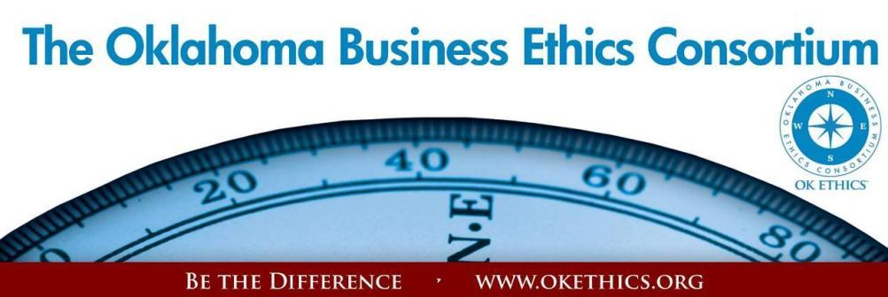

ENTERING OUR TENTH YEAR OF PROMOTING OKLAHOMA VALUES OF INTEGRITY AT WORK!
Agenda – March 7, 2013
- Welcome: Garyl Geist, President, OK Ethics Board of Directors
Chief Operating Officer, Oklahoma Allergy & Asthma Clinic
- New members:

- Trailblazer: BancInsure, Inc./ C. L. Frates and Company (Lynette Parmley)
- Scout members: Tracie Leonhart - Leonhart Consulting; Carter Cowan - Northstar Wealth Management
ATTENTION MEMBERS: RECRUITING GOALS FOR FY12-13 – PLEASE HELP OK ETHICS FLOURISH!
- 6 NEW LEADING MEMBERS - $1500 LEVEL – Only 3 more to go!
- 10 NEW FRONTIER MEMBERS - $400 LEVEL – Only 6 more to go!
- 10 NEW (OKC) SCOUT MEMBERS - $75 LEVEL – Only 5 more to go!
Did you know that 501c3, non-profit organizations can join for free at the Frontier level?
- Announcements:
- National Student Ethics Bowl: Congratulations to The University of Oklahoma!
Update from Dr. Stephen Ellis – OU Student Ethics Advisor
The purpose of these awards is to recognize businesses that are positively impacting their communities in ways that inspire integrity. There are two categories for this award: those having a positive influence on school campuses or those that impact the community as a whole.  See “Awards” Tab at www.okethics.org  for more information! | This award is based on Malcolm Baldrige Quality Criteria and is intended to:
  • | Share best practices
  • | Inspire trust of consumers and shareholders
  • | Build on solid reputation of business
  • | Improve quality of ethics initiatives
  • | Encourage others – including employees and vendors

- OK Ethics Compass Awards! Watch for Best Practices workshop video online!
Highlights from Ben Robinson, Brigadier General, USAF (Retired) & former Site Leader for Boeing

- Volunteer Appreciation
OK Ethics relies primarily on volunteers to achieve the organization’s successful pursuit of Oklahoma’s values of integrity at work. It takes leadership and teamwork to host these exciting events and we salute your dedication in achieving OK Ethics’ mission! Listed below are today’s volunteers who consistently provide service to our members:
Agendas: Many thanks to the volunteers from Metro Technology Centers who provide our monthly agendas.

Ambassador Team: These friendly people welcome our guests each month and assist in helping them locate seats. They also arrive early to help distribute agendas and assist with name tags.
Linda | Streun | Ideal Homes | Chief Ambassador
Brent | Martens | Accounting Principals | Ambassadors (Lead – Team 2)
Ann | Gray | Oklahoma Baptist University | Ambassadors
Jenny | Hatton | Boeing | Ambassadors
Valorie | Hodges | Valir Health | Ambassadors
Tammy | McKeever | Enterprise Holdings | Ambassadors
Jacob | Pasby | Arnold Oil Company | Ambassadors
Daniel | Yunker | Kimray, Inc. | Ambassadors
Nancy | Hyde | Hyde & Company, CPA's | Ambassador (Executive Team)
Ben | Robinson | Sentry One LLC | Ambassador (Executive Team)
Tom | Shehan | Nextep Inc. | Ambassadors (Executive Team)
Registration Team: These dependable individuals diligently record our guests’ attendance and handle the collection of fees:
Mark | Neumeister, CPA | D. R. Payne & Associates | Registration Chairperson
Mary | Vaughan |  | Guest Registration (Cash & Visitors)
Joe | Walker | Arledge & Associates | Pre-paid Registration Chairperson
Marvinette | Ponder | Devon Energy | Pre-paid Registration – Lead

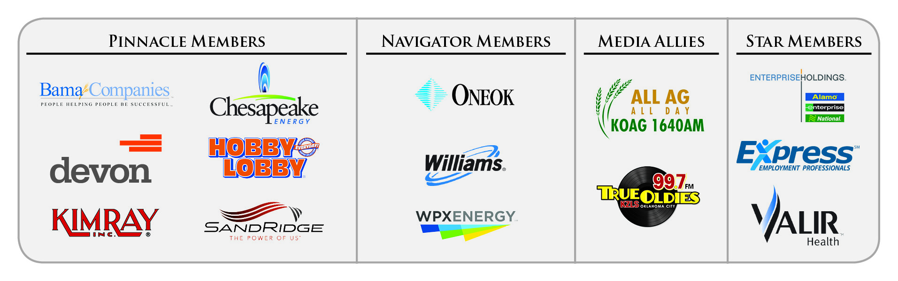
Special Initiatives:
Michael | Mount | Oklahoma Accountancy Board | CPE's
Susan | Pate | Stinnett & Associates | Accountant
Jamie | Potter | Eide Bailly LLC | Facilities & Logistics Chair
Jalisha | Petties | OK Ethics | Member Care Coordinator
Volunteer Appreciation (continued):
Anna | Rosenthal | OK Ethics | Special Projects & Name Tags
Connie | Root | Walker Companies | Speaker Gifts
Shirley | Mears | Champlin Broadcasting | Announcements on Morning Drive (99.7)

TUNE IN! Our own Bob Byrne and Shirley Mears featured on the morning drive for True Oldies Channel FM 99.7 – Tune in between 7:00 and 8:00 a.m. to learn more about Oklahoma’s legacy! Also, hear interviews with speakers thanks to Champlin Broadcasting and the folks with the Oklahoma Heritage Association who provide the research for our historic profiles!
DID YOU KNOW?
OK Ethics’ outreach to university students has greatly increased. Part of your membership dues are earmarked to sponsor student ethics activities on thirteen Oklahoma campuses and our Foundation sponsored a Statewide Educators Ethics Symposium that was attended by approximately 70 academic leaders representing nearly 20 educational institutions.
- Upcoming Events: Tulsa Chapter
Thursday - March 28
Doubletree Hotel – Downtown Tulsa
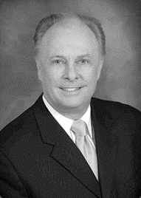
“ReLaunch”
Dr. Mark Rutland
President, Oral Roberts University

As the third president of Oral Roberts University, Dr. Rutland joined the campus during a time of great turmoil and uncertainty. Under Rutland’s leadership, ORU has experienced an unprecedented resurgence. Since 2009, the university has successfully eliminated $55 million in long-term debt. They have also completed nearly $40 million in campus improvements. In addition to these on campus improvements, ORU has experienced four straight years of enrollment growth. This past fall ORU welcomed the largest incoming freshman class in 10 years and celebrated a freshman retention rate of more than 80% for the third consecutive year.

Dr. Rutland has a history of turning organizations around using ethical principles as demonstrated by his success at ORU. Dr. Rutland will discuss his upcoming book ReLaunch and how these principles could be applied in many organizational settings.

OKLAHOMA BUSINESS ETHICS CONSORTIUM ~ www.okethics.org
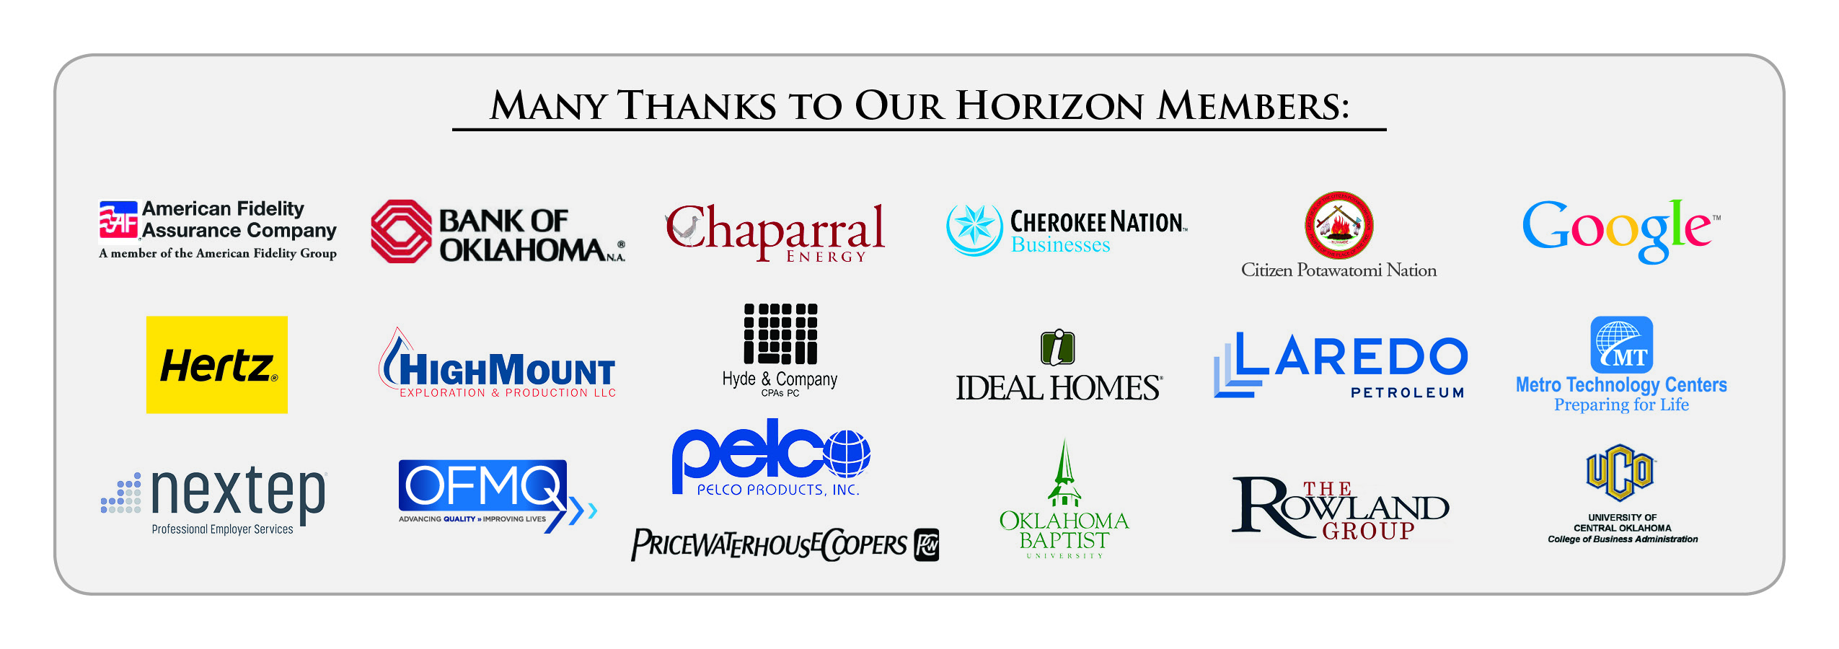
Upcoming Events: Oklahoma City Chapter

Tune in online! | Wednesday, April 17  Petroleum Club - OKC | Wednesday, May 15  Petroleum Club - OKC
BEST PRACTICES  WORKSHOP    Learn from previous award winners and current  Compass Award judges  Carla Brockman,  Devon Energy  and Gary Huneryager  of OGE Energy.  Workshop highlights:  - Shared BEST PRACTICES  - BENEFITS of Compass Award application process  - HOW TO OBJECTIVELY MEASURE THE EFFECTIVENESS OF YOUR ETHICS INITIATIVES vis-à-vis Malcolm Baldrige Criteria. | “Reviving Work Ethic in an Age of Entitlements”  Value Added: Developing People from the Inside Out    Research proves that most business leaders are not satisfied with the performance, productivity, and the service they are getting from their emerging workforce. The problem is not so much a skills gap as it is a values gap. Learn the 7 essential work ethic values within your people to ensure their success, and the success and sustainability of your business.  Presented by Award Winning Keynote Speaker and Bestselling Business Author, Eric Chester  Recommended for 1 CPE in Ethics | Annual  Compass Awards  “THE REPUTATION DOCTOR IS IN”  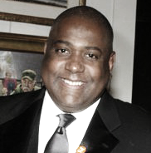  MIKE PAUL  President, MGP & Associates Public Relations; NYC  Special discounts for Horizon Members and early bird registrations.  See website for details  Recommended for  1 CPE in Ethics
Programs Focused on Integrity - (Not affiliated with OK Ethics)

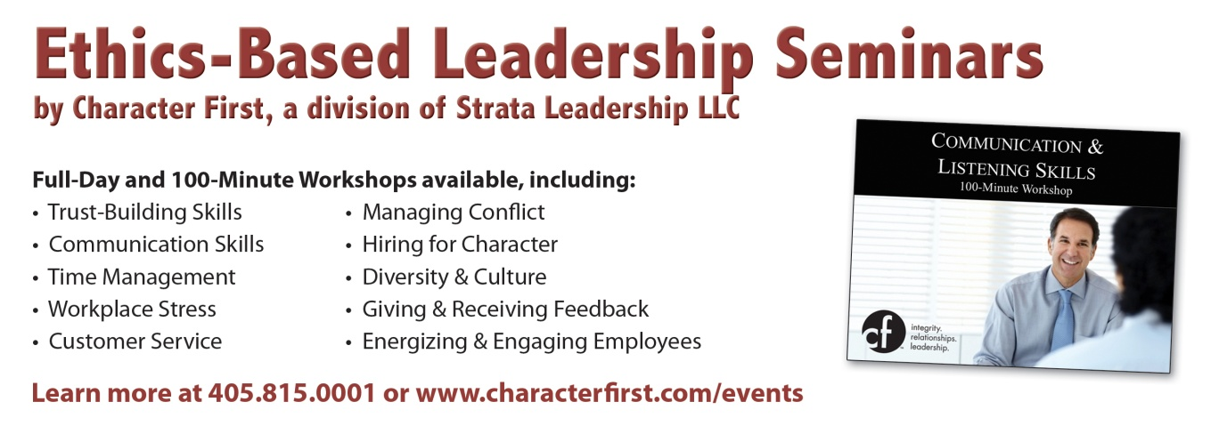
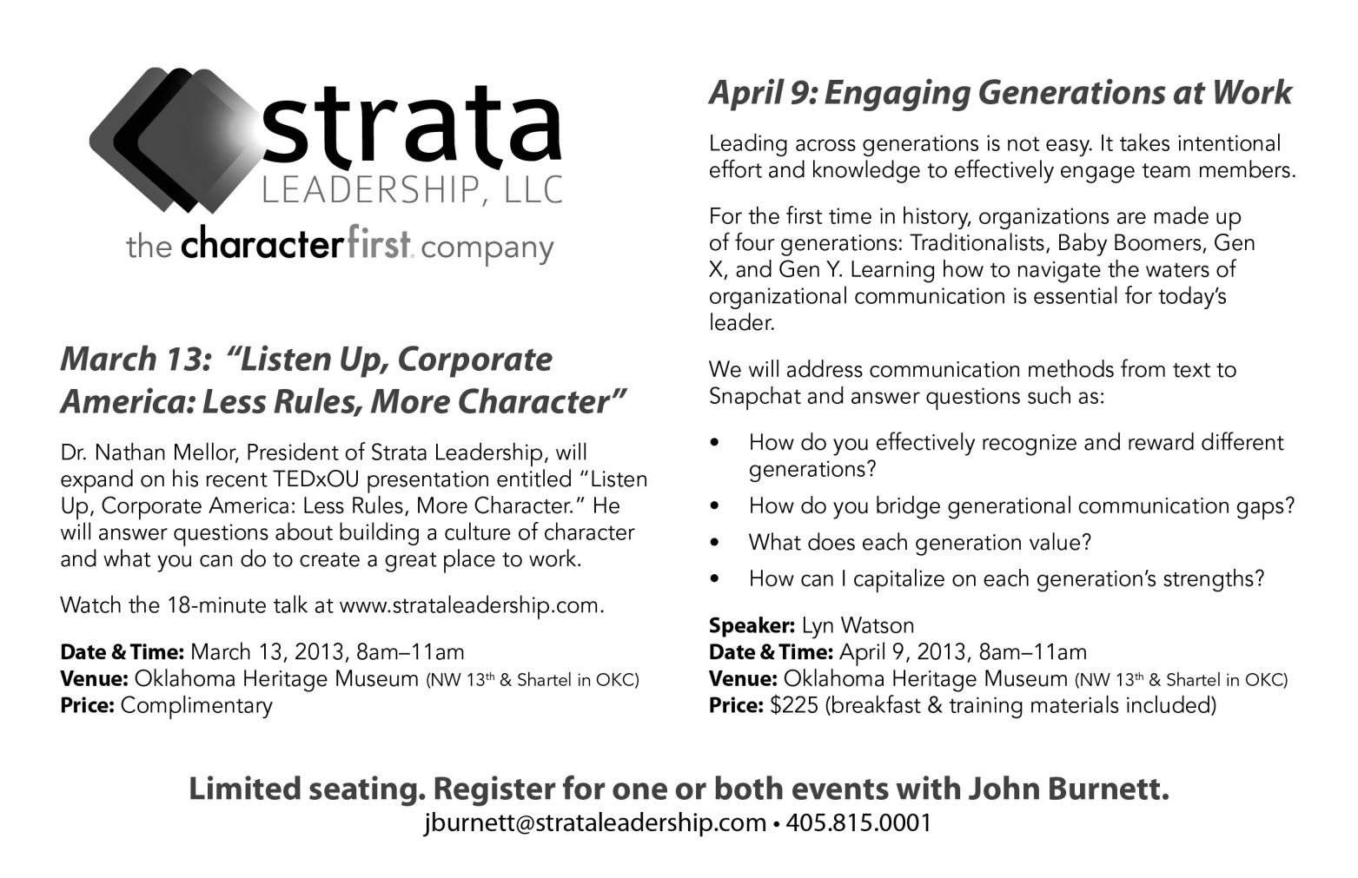
Since the beginning, OK Ethics members have been inspired by our friendship with Character First. Leaders with this organization provided the wisdom and insight for OK Ethic's Guiding Principles. Go to www.characterfirst.com to learn more about tools to help you integrate character and ethics into your organizational culture, or contact John Burnett at 405-815-0001

OKLAHOMA BUSINESS ETHICS CONSORTIUM ~ www.okethics.org

REMINDER: PLEASE PICK UP CPE’S
AT CONCLUSION OF EVENT.

About Our Presenter:


Marilyn Tam, Ph.D. is a Speaker, Author, Consultant, Board Certified Executive/Corporate/Leadership Coach, and Founder and Executive Director of Us Foundation. She was formerly the CEO of Aveda Corp., President of Reebok Apparel and Retail Group; Vice President of Nike Inc. and also a successful entrepreneur who has developed and built four companies.
Marilyn has had an extraordinarily diverse life, from her beginnings in a traditional Chinese family in Hong Kong to her meteoric rise through the executive ranks of the international business world to become an influential corporate leader, speaker, author, corporate consultant, leadership coach, and respected humanitarian.
She is a successful entrepreneur, having developed and built four companies in fields as diverse as a corporate consulting & training company, a web portal company, a supply chain software company and an integrated health and wellness company.
Marilyn speaks and consults globally with Fortune 500 companies, governments and non-profit organizations and on Leadership, Diversity, Life Balance, Change Management and how to integrate social & environmental concerns into businesses profitably.
Marilyn is the co-founder and Executive Director of the Us Foundation www.usfoundation.org, whose mission is to facilitate global action plans and dialogue to address social, economic and environmental issues. Us Foundation is one of the partners for United Nations Habitat-II, and was nominated as a candidate for the “Best Practice Award” from the United Nations’ Habitat II.
She is a director on the national board of SCORE Association, a resource partner of the U.S. Small Business Administration, (SBA). SCORE is dedicated to entrepreneurial education and the development, growth and success of small businesses nationwide.
She served on the international board of The Reebok Human Rights Awards, along with former President Jimmy Carter; renowned musicians Peter Gabriel, and Sting, Rafer Johnson, Chairman of the Special Olympics; and Kerry Kennedy of the Robert F. Kennedy Memorial Center, and Paul Fireman, Chairman of Reebok International Ltd. She was awarded The Reebok Human Rights Award for her humanitarian work.
Whether she is directly improving the lot of workers in her contract factories around the world, or developing and conducting seminars to train other entrepreneurs in business leadership programs internationally, Ms. Tam always gives back. She is committed to the belief that philanthropy is integral to and provides an essential balance and relevance to her work.
Marilyn was an advisor to the country of Bhutan, working with the Ministers and government officials to transition the country into the 21st Century while retaining their cultural and environmental heritage.
According to Brand Channel, she is one of the four most prominent names in brand ethics globally.
Marilyn was recognized as one of the Top 30 Female Entrepreneurs in the USA by Fempreneur magazine. Jack Canfield detailed her work in his book on the strategies for success, “The Success Principles”. She is featured as in the best selling book, “Fearless Women, midlife portraits” by Alspaugh, Kentz, and Halpin; Daryn Kagan, former CNN anchor spotlighted Marilyn as one who dared to dream that they can make a difference, in her book, “What’s Possible”.
She was honored with the Artemis Award for her business and humanitarian work by the Greek government and the Euro American Women’s Council in Athens, Greece, with her likeness on a Greek postage stamp. eWomenNetwork presented her with their Lifetime Achievement Award. Marilyn is featured seven inspirational documentary movies including GLOW Project, The Compass, Vitality and The Gratitude Experiment for her remarkable accomplishments and inner wisdom.
Marilyn’s new book, “The Happiness Choice – The 5 decisions that will take you from where you are to where you want to be” will be released by John Wiley & Sons in February 2013. Her book, “How to Use What You’ve Got to Get What You Want”, is available globally in six languages. And, “Living the Life of Your Dreams” was eBook of the Year 2011 in the Inspirational category.

Program Overview:
Dr. Marilyn Tam has developed four simple, straightforward principles that not only help people stay on a solid ethical track, but provide greater happiness and fulfillment in the process. Rising from the lowest-ranked member in a Chinese family who did not value female children, Dr. Tam went on to achieve executive positions with Aveda, Reebok and Nike. Find out how she garnered her inner strengths to overcome the challenges and live a life of purpose based on unfailing core values.
Recommended for 1 CPE in Ethics at the basic level. Program is suitable for any business leader desiring to promote universal values.

“Purpose + Integrity = Happiness”

Live Your Life Purpose and Follow The Four Principles:

1. Tell the Truth

-Negative consequences of lies: Madoff, Scott Thompson ex CEO of Yahoo
-Can deal with issues as they appear, be proactive and increase probability of long term success
-Integrity and reputation of you and your business depends on it

"If you tell the truth, you don't have to remember anything."--Mark Twain

2. Make Partners

-Large mission, need support
-Find common ground, engage, and collaborate
-Learn from others and get mentors

3. Make Big Mistakes

- To move ahead entails risk & big potential reward
- Analyze, plan, prepare contingencies, then act & respond
- Keep improving or be left behind

4. Die by your own Sword

- Your dream is worth fighting for
- Speak up for what you believe
- Consequences of not acting is detrimental to self, business and the world (The Reebok story)

For more information – http://www.marilyntam.com/index.html and Marilyn Tam’s books – “The Happiness Choice” and “How to Use What You’ve Got to Get What You Want”
This page is considered proprietary material from Marilyn Tam & Company www.MarilynTam.com

LIKE OK ETHICS ON FACEBOOK
Interested in Receiving OK Ethics Monthly Meeting Notices?

OKC:
Contact Jalisha Petties, Member Care Coordinator
at (405) 889-0498 or via email okethics@yahoo.com

Interested in joining OK Ethics?
Contact Lynda Mobley, Vice President of Membership; Lynda.Mobley@oneok.com



General Program Disclaimer:
Members of the Oklahoma Business Ethics Consortium frequently share information concerning various issues and developments that may have legal implications. The discussions, commentary, and handouts at Consortium meetings or presentations to other organizations are for general informational purposes only. They cover only some aspects of the subject topic, and do not constitute a complete legal analysis of the topic or how it might apply to any particular set of facts. Before taking any action based on information presented during a Consortium event, participants are encouraged to consult a qualified attorney. The observations and comments of presenters at Consortium meetings and networking are the views and opinions of the presenter and do not constitute the opinion or policies of the Consortium or any of its members. Presenters are respectfully requested to avoid profanity, preaching, politics, put-downs and self-promotion during their lectures

OKLAHOMA BUSINESS ETHICS CONSORTIUM ~ www.okethics.org

Oklahoma Business Ethics Consortium Guiding Principles
Adopted July, 2004
To ensure that the Consortium fosters positive characteristics of integrity in the successful achievement of its goals, these Guiding Principles were discussed and adopted (with revisions) during a milestone planning session held by Consortium leaders in Stroud on June 18, 2004. These principles were developed based on the Character First's values and philosophies.
I. Responsibility to Self and Others:
- Service:
  - Passion for promoting ethics and integrity
  - Encouraging the promotion of ethical behavior through personal actions and
  - Sharing ideas and resources
  - Responsibility and accountability for fulfilling the mission of the Consortium.
- Collaboration:
  - Achievement of common goals through the promotion of ethical, mutually beneficial relationships
  - Service to the Consortium over promotion of self-interest
  - Cooperation emphasized over competition in promoting ethical business conduct
  - Members collaborate by being constructively engaged in discussions regarding ethics
  - Seeking consensus in interactive discussions regarding ethical matters.
- Respect:
  - Members may become aware of confidential information shared by others in an effort to determine an ethical course of action. We ask members to be sensitive in recognizing and respecting the efforts made toward achieving ethical behavior. In that vein, public disclosure of this information is discouraged.
  - We respect other members and the process by:
    - Exhibiting listening skills and actively listening to discussions
    - Being open to other points of view and outcomes
  - We are an inclusive organization and demonstrate this by welcoming members who are in different stages of learning as applied to ethical behavior.
II. Lead with Integrity
- Dependability:
  - Members are asked to demonstrate their support of this initiative by consistently attending meetings.
- Initiative:
  - Recruiting other members who have demonstrated a desire to promote ethical behavior in their organizations.
  - Recognizing what needs to be done to help promote the Mission of the Consortium and taking action to assist in that effort.
- Honor:
  - Members are asked to honor the Consortium through the practice of integrity and ethical behavior in their business dealings.
  - We express gratefulness to our hosts, sponsors and speakers; as well as to those whose volunteer service makes OK Ethics a stronger organization.
  - Realizing that each of us is in a mode of continual learning, we demonstrate humility, care and compassion when sharing our thoughts and knowledge.
- Courage:
  - Speak the truth with confidence and encourage others to do the same.
III. Inspire Trust
- We serve and promote the cause of truth with integrity, objectivity and fairness to all persons.
  - We hold ourselves accountable by consistently honoring our word.
  - We extend trust abundantly to those who have earned it.
  - Trust, once earned, will not be taken for granted, manipulated or abused.

